

Bonus Procedures
Through Enterprise Performance Management System (EPM)

Introduction

- The bonus scheme is an informal appreciation of the Company for excellent performance and loyalty and continuation on work of the employees; and as such it is subject to the discretion of the Top Management in the Company.

PID & IT departments generate an automated system of Enterprise performance Management for implementing the The bonus configurations below :

      - Activate the Project bonus
      - Determine the relevant positions and eligible employees
- Generate the project evaluation KPIs
- Define the KPIs and positions weights
- Collecting actual data of KPIs for performance assessment
- Bonus Distribution and calculation
- Special bonus calculation
- Bonus project eligibility
- Data approval status reporting

Login to EPM system

- All users can login to EPM system through Algihaz portal as per the fig below

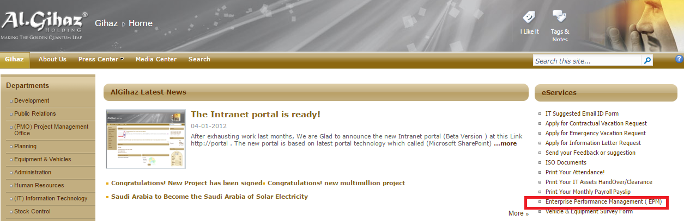

- Enter the user name and password



Activate the Project bonus

- All project information for any new project should be created in EPM system by PID department.
- All necessary fields appear in the fig below should be updated by BUs .

- The total bonus value will be calculated automatically and distributed to TCC & FAC amounts as per defined limits approved in the bonus scheme

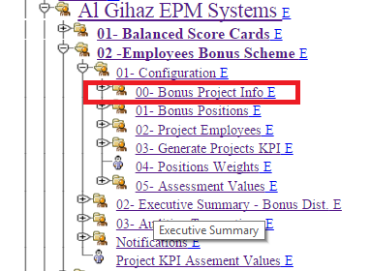

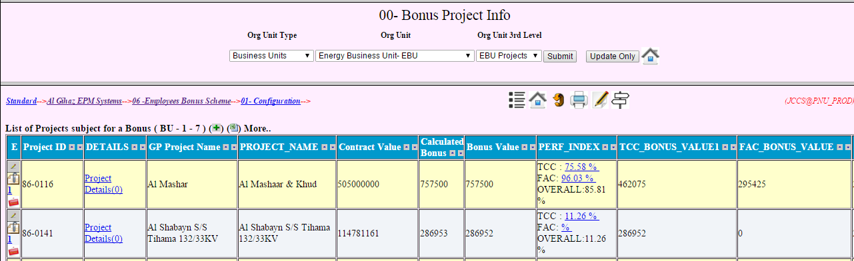

- After updating the project information , EBU should complete the 1st level of approval and PID will be responsible for the 2nd level of approval as per defined approval cycle below.

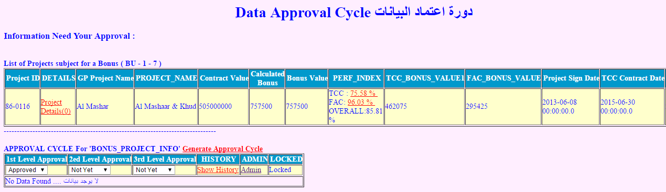

Determine the relevant positions and eligible employees
- All eligible positions and employees should be determined by EBU as per the approved time limit in the scheme.
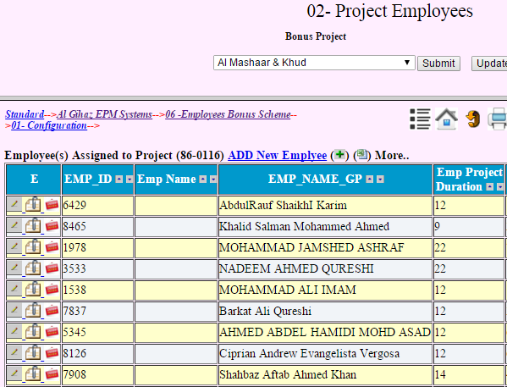

- All employees should be approved by EBU .
- There is an automatic notification will be sent to HR for the 2nd level of approval to make sure that all mentioned employees under the cost center of the relevant project.
- If HR reject any employee , the status of the 1st approval will be changed automatically to be NOT YET and the bonus calculation of that employee will be on hold.
- HR should validate as per the bonus validity rules for all mentioned employees .
- PID will validate the approved data with all attached supported documents provided by HR.

Generate the project evaluation KPIs

- PID should generate all KPIs and determine the corresponding definitions, formulas ,thresholds , direction, etc… as per approved scheme.

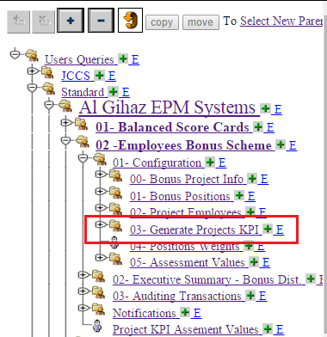

- EPM system have a KPIs library for different KPIs classes like TCC , FAC , Managerial , Finance , Operational ,etc..
- PID will select the appropriate KPIs corresponds to the project , BU or department and generate it for all necessary positions as below

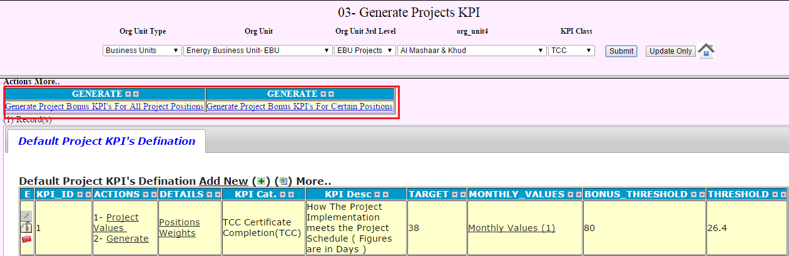

Define the KPIs and positions weights

- PID will define all KPIs and positions weights as per approved scheme for project and support team.

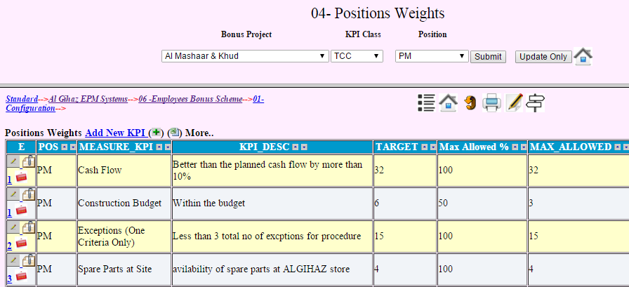

Collecting actual data of KPIs for performance assessment

- The data owner of KPIs should update the values of the following figures in the project balanced scorecard:
- planned
- threshold
- actual

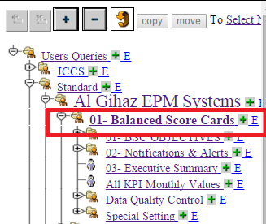

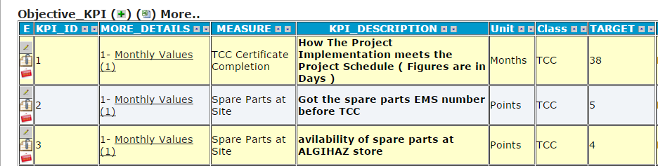

- The achievements % will be calculated automatically as below

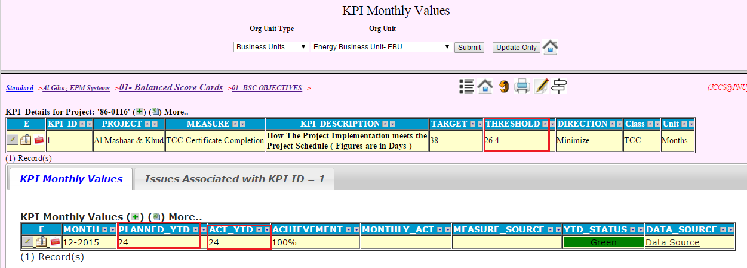

- Data owner of BUs or departments should complete the 1st level of approval and attach the summary report and all data sources using the attachment feature below:
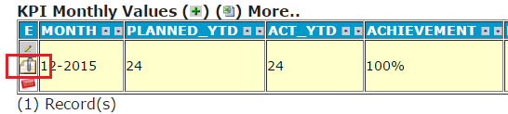

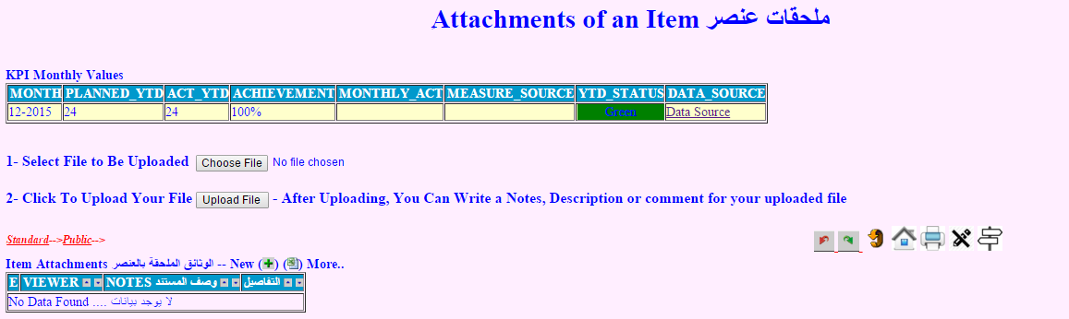

- PID should validate all data sources to make sure that the actual and planned values are reflecting the reality
- All issues impacting the off track values should be detected for analysis and preventive actions.
- PID should conduct the different types of analysis below for preventive actions:
- Dimensional analysis
- Root cause analysis
- Impact analysis
- What if analysis.

Bonus Distribution and calculation

- After completing the phase of collecting and validating the data required for assessment , EPM system will calculate the bonus values as per the approved equation for all positions and executive summary report will be generated automatically as below:

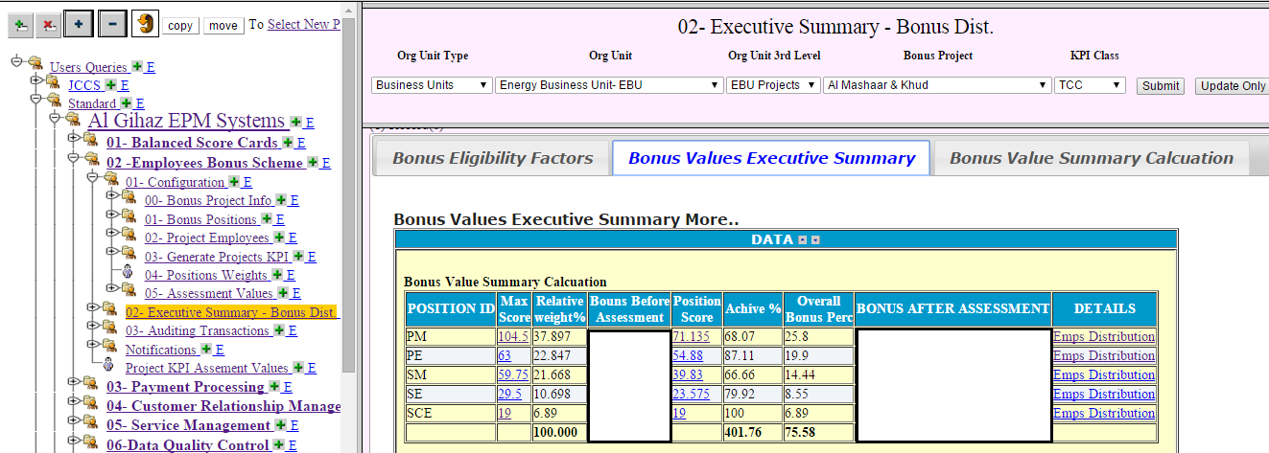

- PID will inform all eligible employees with their achievements details to get their feedback for any future enhancement

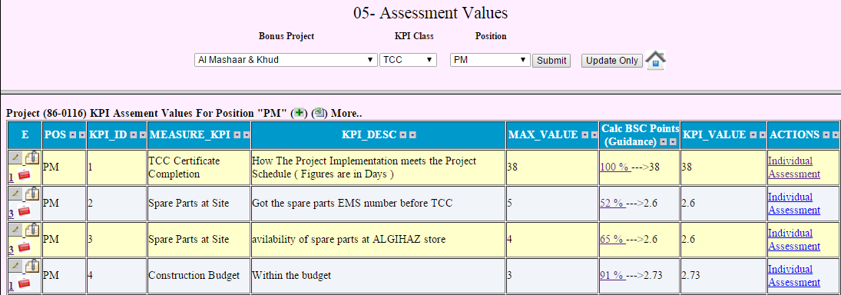

Special bonus calculation

- The bonus scheme could contain a special bonus calculation , it will appear as one of the KPIs, but it will be calculated automatically as per the approved rules

Bonus project eligibility

- The project will be eligible to receive bonus if and only if it conform the specific criteria, otherwise no bonus will be considered for that project , all such criteria as per approved scheme as shown below:

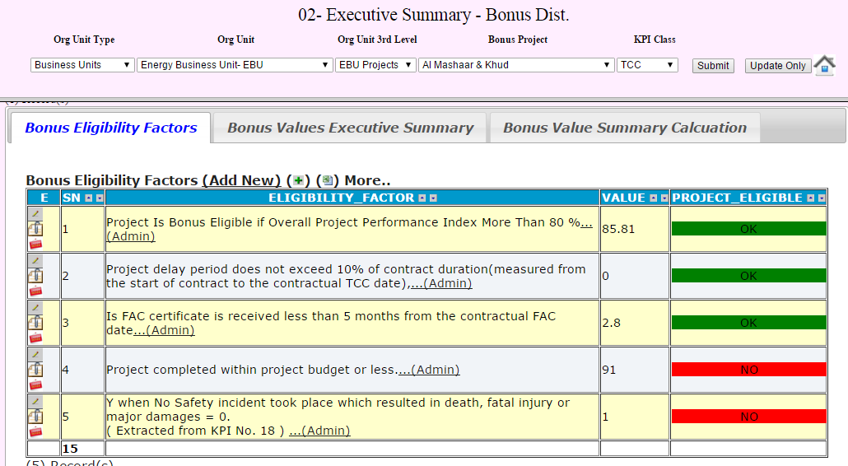

- If the project delay period exceed the approved period measured from the start of contract to the contractual TCC date or FAC date , PID will check the risk registration to make sure that the top management was informed on time with that risk and corrective actions were taken as per the EPM process:

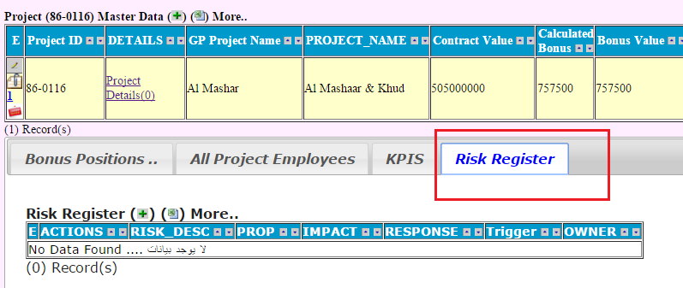

Data approval status reporting

- All data owners can review the status of pending approvals required in all level of authorizations as below:
